M1: Hands-On Lab Guide

# Lab 1 Exercise: Clone a LinkedIn Feed Page with Lovable

**TASK**: Using [Lovable](http://www.lovable.dev), you will prompt the cloud-based tool to replicate the LinkedIn Feed page. Your goal is to experience firsthand how AI prototyping tools can rapidly translate an existing interface into an interactive build.

### Step 1: Sign in to Your [Lovable](http://lovable.dev) Account

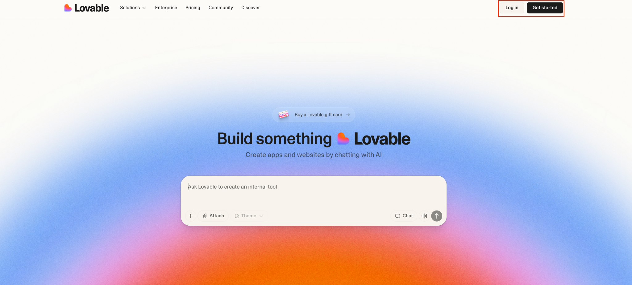

1. As a **prerequisite to starting Module 1,** you should have created your Lovable Pro account. If you have not, ensure you have created your account and have **the paid Pro addition.**

### Step 2: Develop Your Prompts

**Prompt and screenshot of the website you want to clone.**

1. Paste the following prompt into the box:

Build a prototype to match this website design. Match it exactly in layout, styling, typography, and responsiveness. Recreate all UI elements pixel-perfect, ensuring the prototype mirrors the original site’s look and feel. Use clean, reusable components with proper semantic HTML, Tailwind CSS, and responsive breakpoints. Ensure the output can be extended with interactive elements later if needed.

1. Click the plus icon (+) in the bottom-left corner of the prompt box and choose either “Attach File” to upload a screenshot of your own LinkedIn feed or the “Take a screenshot” button to do it directly.

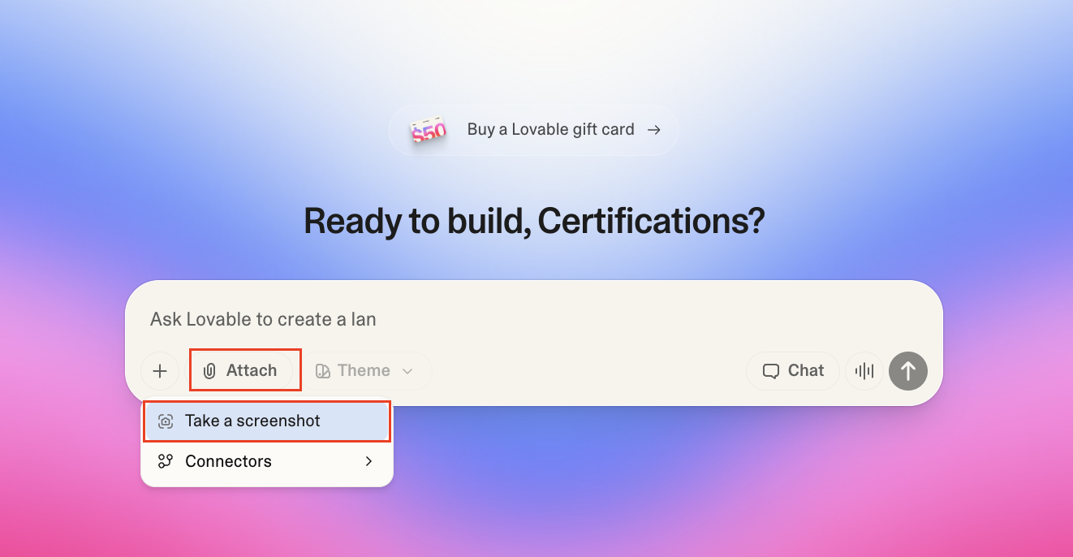

1. Press enter to send the prompt.

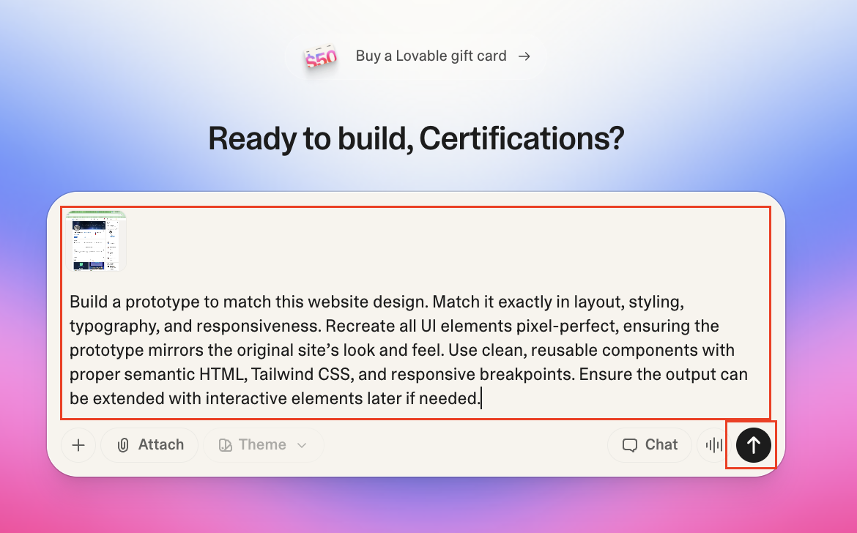

🔎 **Note Lovable’s Output:**

Observe how Lovable replicates many core website features and specific design elements from the original webpage (like LinkedIn's header, sidebars, feed structure, colors, and spacing) based *only* on the provided URL or screenshot. Notice that you didn't need to explicitly list these details in your prompt to include them in its initial clone.

**Core Features Replicated Include:**

* Authentic LinkedIn header with logo, search bar, and navigation
* Left sidebar with user profile card, recent activity, and groups
* Main feed with post composer and dynamic posts with engagement
* Right sidebar with LinkedIn News, recommendations, and promoted content
* Responsive layout maintaining LinkedIn's exact spacing and proportions

**Design Elements Replicated Include:**

* LinkedIn's signature blue color (#0A66C2) is used throughout
* Authentic typography with proper font weights and sizes
* Exact spacing using LinkedIn's 4px grid system
* Proper hover states and micro-interactions
* Clean white cards on a gray background, matching LinkedIn's aesthetic

You don't need to do anything with this list! It's simply to highlight the impressive capability of AI prototyping tools like Lovablet to understand and replicate complex UIs from minimal input – a key advantage for rapid iteration.

# Lab 2 Exercise: Add a Wishlist Feature to Your Cloned LinkedIn Prototype

**TASK**: Returning to your prototype in [Lovable](http://lovable.dev), you will prompt the tool to add a new wishlist feature to your cloned LinkedIn Feed page. Your goal is to experience how AI prototyping tools can quickly iterate and add new functionality to an existing build.

**ℹ️ IMPORTANT: If you wish to create a feature other than the “Feed Filter” button, you will need to write your own prompt, rather than following the steps below.**

### (Optional guidance for those who want to add the filter button) Step 1: Prompt for the Filter Button

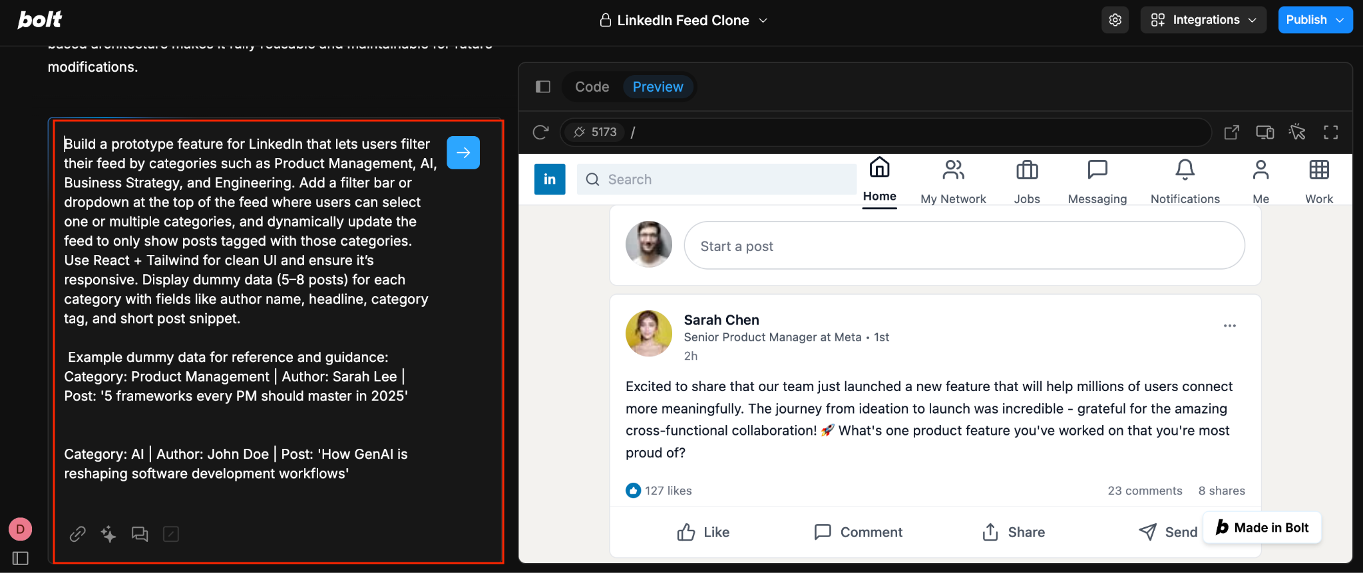

1. Return to your LinkedIn prototype in Lovable. If you closed the tab, you can find your previous projects from the home screen “All Projects” tab on the left sidebar, or scrolling down below the prompt box.

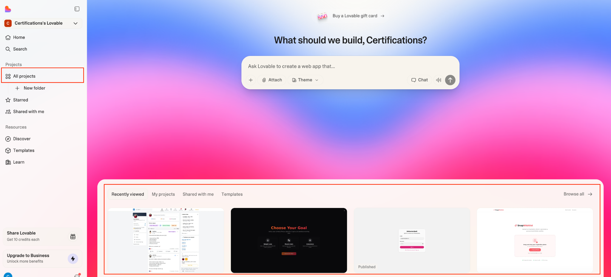

1. Write a follow-up prompt in the text box on the lower-left corner that instructs Lovable to build a new prototype “Filter feed bar” feature for LinkedIn. Paste the following:

Build a prototype feature for LinkedIn that lets users filter their feed by categories such as Product Management, AI, Business Strategy, and Engineering. Add a filter bar or dropdown at the top of the feed where users can select one or multiple categories, and dynamically update the feed to only show posts tagged with those categories. Use React + Tailwind for clean UI and ensure it’s responsive. Display dummy data (5–8 posts) for each category with fields like author name, headline, category tag, and short post snippet.

Example dummy data:

* Category: Product Management | Author: Sarah Lee | Post: '5 frameworks every PM should master in 2026'
* Category: AI | Author: John Doe | Post: 'How GenAI is reshaping software development workflows'
* Category: Business Strategy | Author: Priya Sharma | Post: 'Why platform plays win in the AI era'
* Category: Engineering | Author: Carlos Vega | Post: 'Scaling microservices with event-driven architecture.'

1. Again, press the blue arrow in the box, or enter on your keyboard, to send the follow-up prompt.

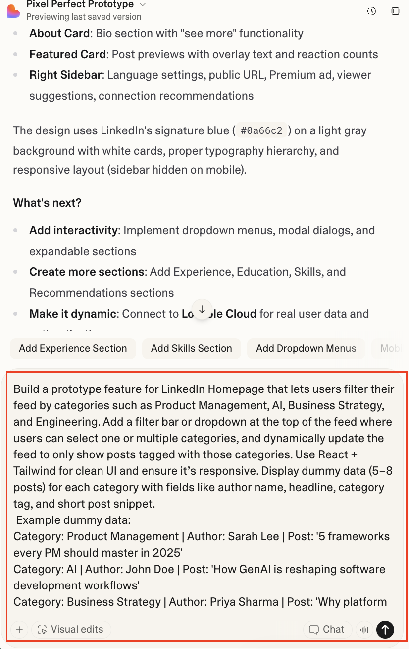

You should now see the feature added to your prototype. But this is more than just a mock-up; try clicking the filters and check out how the content adapts in real time!

